AMT Newsletter Volume 1 – February 2026

Solving a maddening problem…
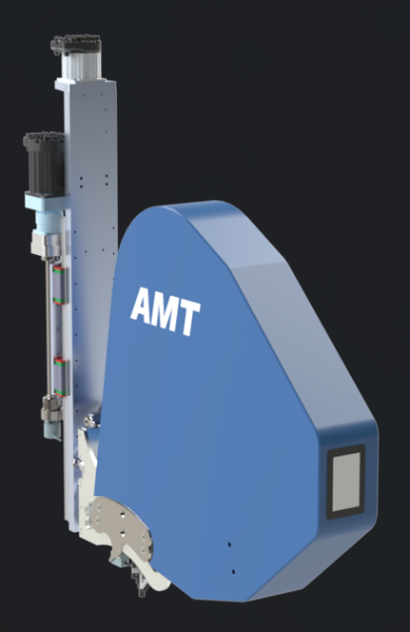
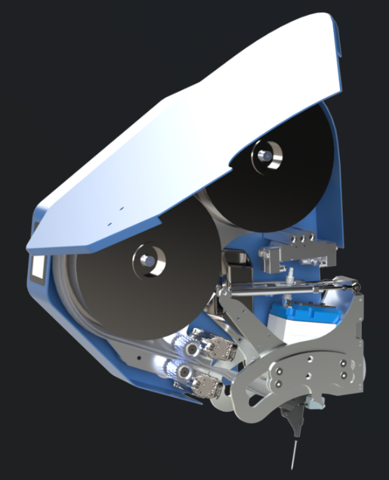
During my 30 years at the All-Fab Group I kept trying to find ways to get our PreFab lines moving faster. It’s a tricky problem as unlike many other production lines, there is a lot of variation in design from one wall to the next given the production planning required to get the right sequence for the job site. Cycle times at the various stations are constantly changing which makes it very hard to balance the line.
At AMT Robotics we’ve created a patent pending Dual Coil Articulating Nail Head to drastically speed up the Sheathing Station no matter how complex the nailing pattern. Given that sheathing is often the slowest station this will increase production on the entire PreFab line.
Here’s a summary of our thinking.
Current Problem – Heads on nailing bridges run out of nails at different times and the bridge has to be stopped each time.
Previous Solution 1 – Make bigger coils of nails.
Trade Off – Heads can only get within 22” of each other and less nailing heads can be used on a panel.
Previous Solution 2 – Use robots with tools changers to automatically swap out coils.
Trade Off – Expensive & still only uses up to 2 robots to nail the panel which makes for a slow process.
Previous Solution 3 – Put Nailers on both sides of a nailing bridge to fit more nailing heads.
Trade Off – Heads are not over the same stud and some are confined to specific task like nailing top and bottom plates or tops and bottoms of rough openings.
AMT Robotics Solution – Orient coils vertically so heads can be positioned within 6 inches of each other.
Additional Benefit – There’s room for a 2nd Mega Coil that automatically feeds into the nailer when the 1st one runs out (more nails!) PLUS all the back up coils can be reloaded at the same time
But wait there’s more – There’s room for up to 8 nailing heads on 1 side with all heads sharing the work.
There still more – More than one 6” nail head can fit above or below rough openings to speed up the fastening of those areas.
Yup, even more – We can stop to reload 2nd coils between panels, so the bridge does not have to go back to where it left off.
Oh, and then there’s this – We have room to piggyback additional tools (to screw, glue, and router) on each nailing head and still have them within 12” of each other.
And I don’t want to forget – There is room available on the other side of the bridge for more tools.
By the way… – The entire nail head pivots on a cam so the bridge does not have to be repositioned to nail both sides of a vertical seam. In other words, one or more nail heads can nail one side of the seam while the other ones nail the other side. And yes, we can pivot to nail horizontal seams too.
Hopefully our approach makes sense – we are always open to new ideas on how to make these systems even better. We’ve also come up with other ways to speed up cycle times and make use of underutilized space at each station but I can save that for another day…

