AMT Newsletter Volume 5 – August 2026

Solutions for a Resilient Supply Chain – The New Affordable AMT ForwardLeap Sheathing Bridge
Those of us who have spent decades in our industry know it is one characterized by seasonal and cyclical fluctuations. Living through multiple downturns and periods of growth forces us to refine our thought processes and shapes our character. When times are tough, we need to question previous assumptions and be willing to adapt to survive. When demand surges, we get inventive on ways to meet the opportunities in front of us.
At AMT Robotics we are focused on providing the right solutions for customers – automated equipment that allows them to get to the next level of safety, quality, productivity and capacity without jeopardizing the strength of their balance sheet. One example of this is our recent decision to offer the ForwardLeap Sheathing Bridge as an entry level alternative to our HyperLeap Sheathing Bridge.
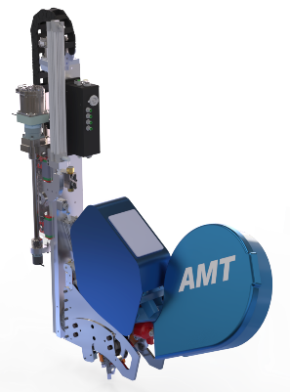
The Same Processing Speed in a more Affordable Package – We are proud of our Patent Pending Continuum Dual Coil Articulating Nailing Head. With the ability to switch between two 1,500 nail coils in a 6” wide head it sets a new standard for tool density (8 heads on one side of the bridge with piggyback options for additional tooling) and drastically fewer stoppages for reloading (multiple secondary coils can be reloaded at one time).
However, many customers do not need more than 4 heads working together on the same side of the bridge to achieve the volume they require. An AMT 4 head bridge is faster than our competitors’ machines with 6 heads split between two sides of the bridges. For these customers, 7” wide Single Coil Articulating Nail Heads give them the tool density they need to get multiple heads above and below rough openings. Nailing speed is the same as our Dual Coil Heads utilizing the same operating software. The lower profile bridge fits in tighter factory spaces and more frequent but faster nail loading cycles do not prevent them from achieving their production goals.
Designed for Future Upgrades like all AMT Solutions – The ForwardLeap is designed to accommodate additional tooling as your business grows and evolves. Compared to the HyperLeap Bridge, the ForwardLeap is a simpler design requiring fewer parts with less weight and a more compact assembly. The reduction in price (particularly with multiple heads) is significant which puts a fully automated sheathing station within reach for any wall panel business.
We are always open to refining our ideas on how to make these systems even better. Reach out when you’re ready to discuss which of our solutions is right for your operation.

