AMT Newsletter Volume 2 – March 2026
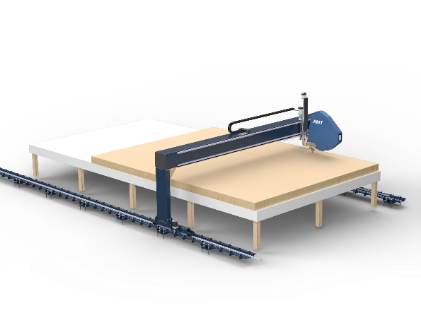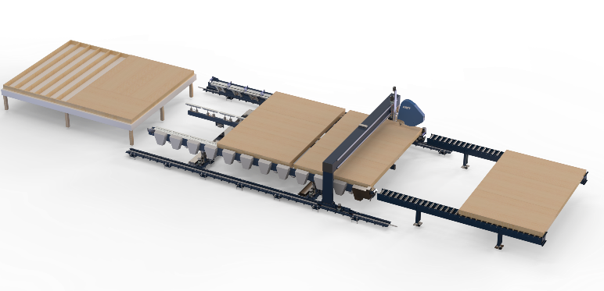
Canadian Automation is More Affordable than you Think.
European quality at Canadian prices. How is this possible? By necessity, by design and by being adaptable.
Being an owner in the All-Fab Group for almost 30 years I learned that the best ideas often come from the factories that have space and budget constraints.
Here are some of our design criteria to provide the best long term solution for our customers while keeping costs down.
– You don’t save labour unless a Sheathing Bridge is fully automated
– Nailing heads that hold 2 mega coils mean multiple coils can be reloaded at the same time
– A Bridge that can be installed over an existing wooden or steel table
– A Bridge that can accept additional tooling in the future – add functions and/or capacity as needed
– Robust Off the Shelf Parts. Custom parts create extra cost, availability issues and frustration down the road. Equipment that needs minimal maintenance and can be repaired locally.
The below are just 2 examples of how we can tailor affordable solutions for each unique business.
Customer A – Builds wall panels on an old squaring table or wooden table. They enjoy the flexibility of building all kinds of shapes and sizes on their existing workstation but nailing the sheathing by hand slows down the rest of production, is hard on the back, and results in missed studs and inconsistent spacing.
Solution – An AMT Gen3 Sheathing Bridge over an existing table for $162,000 plus freight and tax. This bridge can also drive sheathing nails into tall walls, rake walls and floor cassettes oriented 90 degrees to standard walls. Once the panel is squared the Dual Coil Articulating Nail Head fastens the sheathing while the operator can do other tasks. ROI with increased capacity, labour savings and improved quality is less than 2 years operating on 1 shift (1 year for a 2 shift operation). Additional heads can be added as needed.
Customer B – Customer A two years in the future. The sheathing bridge has been paid for and demand continues to grow due to better response times and improved quality.
Solution - An AMT squaring table with a powered conveyor, auto clamping and multi panel staging for $150,000 saves more labour and further increases capacity. After framing the wall and tacking the sheathing on the existing wooden or steel framing table the panel is pushed onto the start of the powered conveyor, and it moves by itself down the line where it waits in the buffer zone until the previous panel is ejected from the sheathing station. It then moves to the end stop, is automatically squared and clamped and the sheathing bridge resumes its work without any operator intervention. After sheathing the panel ejects onto roller conveyors to be stacked onto a bundle. ROI with increased capacity, labour savings is between 2 and 3 years on 1 shift. Adding heads further improves line speed and ROI.

