AMT Newsletter Volume 6 – September 2026

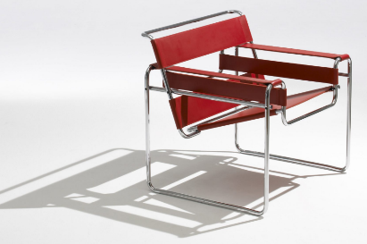
BAUHAUS – Multi-Disciplinary & Form Following Function Philosophy
In 1919 Walter Gropius founded the revolutionary art and design school in Germany that merged fine arts with craftsmanship and mass production. He established the visionary cross disciplinary approach and championed the philosophy that form follows function which has shaped modern architecture, furniture and graphic design. An example of this approach was bringing bicycle builders together with furniture designers who then invented new ways of constructing furniture which were quite different than the methods and materials that were used in the past.
At AMT Robotics, our philosophy of equipment design is centered squarely on a multi-Disiciplinary approach. We are focused on providing the right solutions for our customers, which means we collaborate on identifying problems and testing solutions. We recruit our employees to bring a variety of skills into our organization, and we provide training opportunities to expand and build on those skills. Our software and design engineers are required to not only model designs on computer workstations but then see the project through while participating in the build process out in our shop and servicing equipment once it is in a customer’s production environment. It’s amazing how many opportunities you find to improve on a design when you have to physically put it together yourself or perform regular maintenance on site.
Form Follows Function – we are not committed to one particular way of solving a problem. Industrial robot arms are very versatile and continue to become more affordable but we are very aware that when you own a hammer many things start looking like nails. We are focused on providing solutions with the simplest design possible that solves a problem while employing as many off the shelf standard components as possible. X, Y, and Z axis can provide faster and more repeatable outcome than arms that rotate and require spherical compensation to reliably arrive at the same point consistently. Simpler assemblies cost less and are easier to service. Design for fewer parts - the lowest cost and most easy to service part is no part. Locally available non proprietary parts keep uptime high and avoid costly delays due to long supply chains and border crossing.
Variety Fuels Creativity – a mixture of tasks keeps the mind and body active and fuels idea generation. Working with your hands shapes the brain differently than just working on a screen. Interacting with many different people skilled in different disciplines challenges old patterns and drives creative thinking. Our team practicing these habits on a daily basis is what drives us forward to transform the tools of our industry like bicycle makers transformed the chair.
We are always open to refining our ideas on how to make our systems even better. Reach out when you’re ready to discuss how we can provide solutions for your operation.
Add picture of the entire team in matching AMT shirts

