AMT Newsletter Volume 7 – September 2026

A Sticky Situation – Applying Peel & Stick Membranes Horizontally
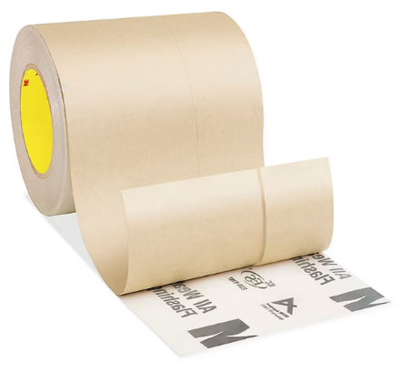
Peel and Stick membranes are a time-saving way of applying air and/or vapour barriers to wall panels in a vertical orientation without puncturing the material with mechanical fasteners. They are typically designed with a removable strip to allow the roll to be started at the top of the wall and, once alignment with the wall sheathing is established by the top strip on the top corner of the wall, the remaining backing is peeled away from the underside of the membrane just before it is pressed to the surface of the sheathing. It is a relatively efficient method for 2 people to apply a membrane provided that the wind on the jobsite cooperates. Once the membrane adheres to the sheathing, rollers are used to apply pressure to the entire surface of the to create a durable bond.
The method described above does not readily lend itself to horizontal applications in a wall panel factory. A customer recently asked us to come up with a solution to speed up the process and potentially reduce the number of people required for this task.
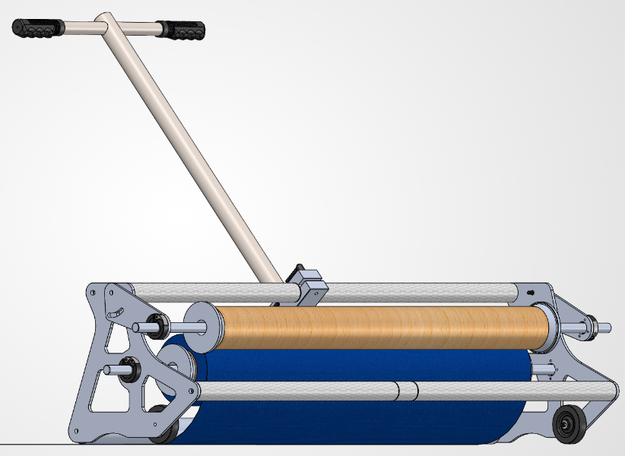
What followed was the development of a tool which removes the backing material from the entire roll while applying the membrane to the wall and simultaneously pressing it tight with a roller – all in one pass. The centre cardboard from the previous roll of material serves as the means to gather up the backing material.
Available with multiple lengths of cross pieces to adjust to rolls of varying lenths, the AMT Peel & Stick applicator allows one operator to apply membrane to wall panels with speed and consistency.
We are always open to refining our ideas on how to make PreFab methods better. Reach out when you’re ready to discuss how we can provide solutions for your operation.

