AMT Newsletter Volume 3 – April 2026

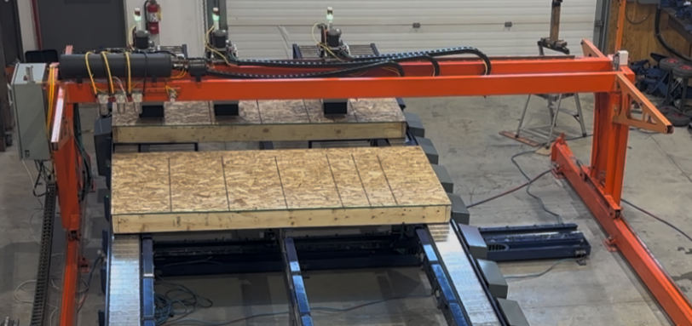
Walk Not, Waste Not
Building wall panels is not like building cars - unless the assembly line builds an SUV after a compact car after a pickup after a limo…
Panels must be sequenced properly to speed up the job site which causes big variations in cycle times for various stations on the PreFab line. Inquiring minds at AMT have created a patent pending Multi Panel Staging System to help solve this issue.

Current Problem – Cycle times on panels vary at every workstation. Downstream stations are sometimes starved for material and production capacity is lost. Other times, upstream stations stop work as the line is “plugged up” downstream.
Previous Solution 1 – Add buffer zones for panels between stations to allow work at each station to carry on independently.
Trade Offs – More conveyors & more space as well as more walking between stations. Buffers are needed after Rough Opening, Framing, and Tacking.
Previous Solution 2 – Combine short panels into longer panels to increase the utilization of each workstation.
Trade Offs – More expensive top and bottom plates that need to be cut apart later with a reciprocating saw. Finished panels that need to be sorted. Cycle times still vary - still need buffers.
Previous Solution 3 –Software to schedule the line so the stations are more balanced.
Trade Offs –Complex, costly and panel sequence & not optimized for the jobsite. Panels need to be sorted.

AMT Robotics Solution – Most panels are far shorter than the max size panel that can be produced at each station. By raising the panel currently being worked on slightly above a powered conveyor the following panels can be moved down the line and into position with minimal space in between them.
Benefit - The unused portion of the station becomes a buffer zone for multiple panels to accumulate. Other buffers are reduced or eliminated requiring less equipment and space & reducing walking distances. Walk Not, Waste Not...
Additional Benefit – Shorter changeover times between panels as the next panel does not have to travel across the entire station to get into position. One panel is ejected with the powered conveyor while the next panel is moved into position.
There’s more – People on the line are closer together which allows them to communicate and help each other more easily.
There still more – Powered conveyors at each station eliminate back strain and eliminate having to call someone to help move material and panels down the line.
Oh, and... – Multi panel staging means having to invest in fewer stations by combining the tacking operation into longer framing or sheathing stations.
One more thing – Our sheathing bridges accommodate tall walls, rake walls & floor cassettes by turning them 90 degrees in the squaring tables. Accommodating more products means investments in automation pay for themselves faster.
By the way… We love talking with customers to develop the best solutions for each unique business.

